COURSE MANAGEMENT SYSTEM
DATABASE TESTING PROJECT
MySQL Workbench | SQL Query Based Test Execution

1. Project Overview
This beginner-friendly project demonstrates how a QA engineer can create a relational database in MySQL Workbench and execute database tests using SQL queries. The project covers schema creation, table creation, constraints, test data, CRUD validation, primary/foreign key validation, negative testing, joins, aggregate queries, data integrity, and test result recording.

2. Tools & Environment
Item | Details
Database | MySQL
GUI Tool | MySQL Workbench
Language | SQL
Project | Course Management System
Testing Type | Database / Backend Data Testing

3. Database Design
Tables used in this project:
Table | Purpose | Key
students | Stores student information | student_id PK
instructors | Stores instructor information | instructor_id PK
courses | Stores course information | course_id PK, instructor_id FK
enrollments | Connects students with courses | enrollment_id PK, student_id/course_id FK
payments | Stores course payment information | payment_id PK, student_id/course_id FK
course_reviews | Stores student course reviews | review_id PK, student_id/course_id FK
Relationship:
students
|----< enrollments >---- courses >---- instructors
| |
|----< payments >---------|
|
|----< course_reviews >-- courses

4. Step 1 — Create Database / Schema
Question / Objective: How do we create the database that will contain all project tables?
CREATE DATABASE course_management_db;
USE course_management_db;
Expected Result: The database is created successfully and the USE command selects it.
Verification Query:
SHOW DATABASES;
SELECT DATABASE();
Expected: course_management_db should appear, and SELECT DATABASE() should return course_management_db.

5. Step 2 — Create the Students Table
Objective: Store student information and validate required fields and unique email.
CREATE TABLE students (
student_id INT AUTO_INCREMENT PRIMARY KEY,
first_name VARCHAR(50) NOT NULL,
last_name VARCHAR(50),
email VARCHAR(100) NOT NULL UNIQUE,
phone VARCHAR(20),
date_of_birth DATE,
gender VARCHAR(10),
registration_date DATETIME DEFAULT CURRENT_TIMESTAMP,
status VARCHAR(20) DEFAULT 'Active'
);
Verify structure:
DESCRIBE students;
SHOW CREATE TABLE students;

6. Step 3 — Create the Instructors Table
CREATE TABLE instructors (
instructor_id INT AUTO_INCREMENT PRIMARY KEY,
first_name VARCHAR(50) NOT NULL,
last_name VARCHAR(50),
email VARCHAR(100) NOT NULL UNIQUE,
phone VARCHAR(20),
specialization VARCHAR(100),
join_date DATE,
status VARCHAR(20) DEFAULT 'Active'
);
DESCRIBE instructors;
SHOW CREATE TABLE instructors;

7. Step 4 — Create the Courses Table
Objective: Each course can be linked to an instructor using instructor_id.
CREATE TABLE courses (
course_id INT AUTO_INCREMENT PRIMARY KEY,
course_name VARCHAR(100) NOT NULL,
course_description VARCHAR(500),
instructor_id INT,
price DECIMAL(10,2) NOT NULL,
duration_weeks INT,
level VARCHAR(20),
created_date DATETIME DEFAULT CURRENT_TIMESTAMP,
FOREIGN KEY (instructor_id)
REFERENCES instructors(instructor_id)
);
DESCRIBE courses;
SHOW CREATE TABLE courses;

8. Step 5 — Create the Enrollments Table
Objective: Connect students and courses. Invalid student/course IDs should not be accepted.
CREATE TABLE enrollments (
enrollment_id INT AUTO_INCREMENT PRIMARY KEY,
student_id INT NOT NULL,
course_id INT NOT NULL,
enrollment_date DATE DEFAULT (CURRENT_DATE),
enrollment_status VARCHAR(20) DEFAULT 'Active',
FOREIGN KEY (student_id) REFERENCES students(student_id),
FOREIGN KEY (course_id) REFERENCES courses(course_id)
);
DESCRIBE enrollments;
SHOW CREATE TABLE enrollments;

9. Step 6 — Create the Payments Table
CREATE TABLE payments (
payment_id INT AUTO_INCREMENT PRIMARY KEY,
student_id INT NOT NULL,
course_id INT NOT NULL,
amount DECIMAL(10,2) NOT NULL,
payment_method VARCHAR(30),
payment_status VARCHAR(20),
payment_date DATETIME DEFAULT CURRENT_TIMESTAMP,
FOREIGN KEY (student_id) REFERENCES students(student_id),
FOREIGN KEY (course_id) REFERENCES courses(course_id)
);
DESCRIBE payments;
SHOW CREATE TABLE payments;

10. Step 7 — Create the Course Reviews Table
CREATE TABLE course_reviews (
review_id INT AUTO_INCREMENT PRIMARY KEY,
student_id INT NOT NULL,
course_id INT NOT NULL,
rating INT,
review_comment VARCHAR(500),
review_date DATETIME DEFAULT CURRENT_TIMESTAMP,
FOREIGN KEY (student_id) REFERENCES students(student_id),
FOREIGN KEY (course_id) REFERENCES courses(course_id)
);
DESCRIBE course_reviews;
SHOW CREATE TABLE course_reviews;

11. Step 8 — Insert Test Data

11.1 Students
INSERT INTO students
(first_name, last_name, email, phone, date_of_birth, gender, status)
VALUES
('Rahim','Ahmed','rahim@gmail.com','01711111111','2000-05-10','Male','Active'),
('Karim','Hasan','karim@gmail.com','01822222222','1999-08-15','Male','Active'),
('Nusrat','Jahan','nusrat@gmail.com','01933333333','2001-02-20','Female','Active'),
('Tamanna','Islam','tamanna@gmail.com','01644444444','1998-12-05','Female','Active'),
('Sakib','Khan','sakib@gmail.com','01555555555','2002-07-25','Male','Inactive');

11.2 Instructors
INSERT INTO instructors
(first_name,last_name,email,phone,specialization,join_date,status)
VALUES
('John','Smith','john@gmail.com','01710000001','Web Development','2023-01-10','Active'),
('Sarah','Khan','sarah@gmail.com','01710000002','Database','2023-03-15','Active'),
('David','Miller','david@gmail.com','01710000003','Python Programming','2022-08-20','Active');

11.3 Courses
INSERT INTO courses
(course_name,course_description,instructor_id,price,duration_weeks,level)
VALUES
('MySQL Database Testing','Learn database testing with MySQL',2,150.00,8,'Beginner'),
('Python Automation','Learn Selenium automation using Python',3,250.00,12,'Intermediate'),
('Web Development','HTML CSS JavaScript Full Course',1,200.00,10,'Beginner'),
('Advanced SQL','Advanced SQL queries and database concepts',2,300.00,6,'Advanced');

11.4 Enrollments
INSERT INTO enrollments
(student_id,course_id,enrollment_status)
VALUES
(1,1,'Active'),
(1,2,'Completed'),
(2,1,'Active'),
(3,3,'Active'),
(4,2,'Active'),
(5,4,'Inactive');

11.5 Payments
INSERT INTO payments
(student_id,course_id,amount,payment_method,payment_status)
VALUES
(1,1,150.00,'Credit Card','Completed'),
(1,2,250.00,'PayPal','Completed'),
(2,1,150.00,'Credit Card','Pending'),
(3,3,200.00,'Bank Transfer','Completed'),
(4,2,250.00,'Credit Card','Completed');

11.6 Reviews
INSERT INTO course_reviews
(student_id,course_id,rating,review_comment)
VALUES
(1,1,5,'Excellent database testing course'),
(2,1,4,'Very helpful and easy to understand'),
(3,3,5,'Great web development course'),
(4,2,5,'Python automation course was amazing');

12. Step 9 — Basic Data Verification
Question: How do we verify that data was inserted correctly?
SELECT * FROM students;
SELECT * FROM instructors;
SELECT * FROM courses;
SELECT * FROM enrollments;
SELECT * FROM payments;
SELECT * FROM course_reviews;
Expected Result: Each query should return the inserted records without unexpected missing or duplicate data.

13. Step 10 — Row Count Testing
Question: Does the number of records match the expected test data?
SELECT COUNT(*) AS total_students FROM students;
SELECT COUNT(*) AS total_instructors FROM instructors;
SELECT COUNT(*) AS total_courses FROM courses;
SELECT COUNT(*) AS total_enrollments FROM enrollments;
SELECT COUNT(*) AS total_payments FROM payments;
SELECT COUNT(*) AS total_reviews FROM course_reviews;
Expected counts: Students = 5, Instructors = 3, Courses = 4, Enrollments = 6, Payments = 5, Reviews = 4.
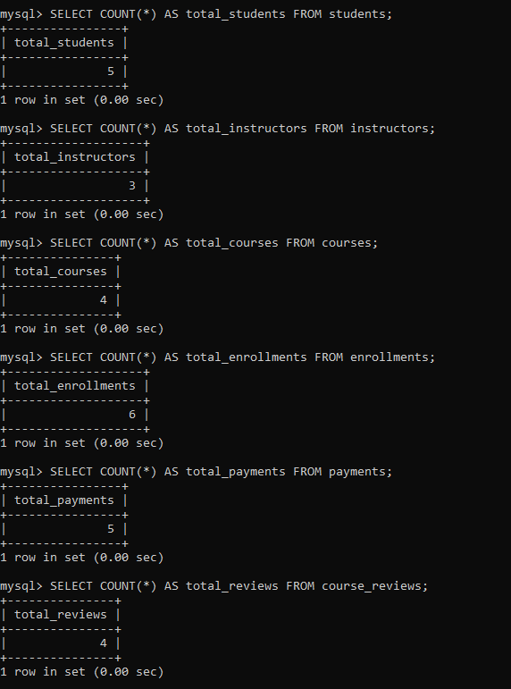

14. Step 11 — Primary Key Testing
Test Objective: Verify that student_id uniquely identifies each student.
SELECT student_id, COUNT(*)
FROM students
GROUP BY student_id
HAVING COUNT(*) > 1;
Expected Result: 0 rows. No duplicate primary keys should exist.
Negative Test — duplicate primary key:
INSERT INTO students
(student_id, first_name, email)
VALUES
(1, 'Test', 'test_pk@gmail.com');
Expected: The database should reject the record because student_id = 1 already exists.
ERROR 1062 (23000): Duplicate entry '1' for key 'students.PRIMARY'
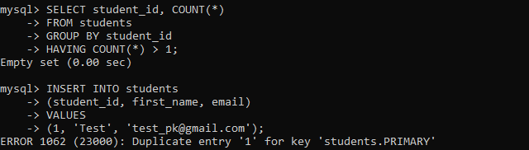

15. Step 12 — NOT NULL Constraint Testing
Test Objective: first_name and email are mandatory.
INSERT INTO students (last_name)
VALUES ('Test');
Expected: Insert should fail because first_name NOT NULL.
ERROR 1364 (HY000): Field 'first_name' doesn't have a default value
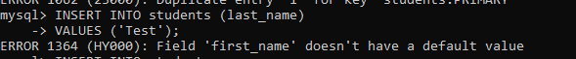

16. Step 13 — UNIQUE Constraint Testing
Test Objective: Email must be unique.
INSERT INTO students
(first_name, email)
VALUES
('Test', 'rahim@gmail.com');
Expected: Insert should fail because rahim@gmail.com already exists.
ERROR 1062 (23000): Duplicate entry 'rahim@gmail.com' for key 'students.email'
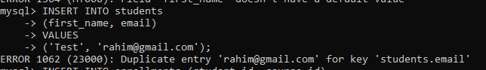

17. Step 14 — Foreign Key Testing
Test Objective: enrollment.student_id must exist in students.
INSERT INTO enrollments (student_id, course_id)
VALUES (999, 1);
Expected: Insert should fail because student_id 999 does not exist.
ERROR 1452 (23000): Cannot add or update a child row: a foreign key constraint fails (`course_management_db`.`enrollments`, CONSTRAINT `enrollments_ibfk_1` FOREIGN KEY (`student_id`) REFERENCES `students` (`student_id`))
Another negative test:
INSERT INTO enrollments (student_id, course_id)
VALUES (1, 999);
Expected: Insert should fail because course_id 999 does not exist.
ERROR 1452 (23000): Cannot add or update a child row: a foreign key constraint fails (`course_management_db`.`enrollments`, CONSTRAINT `enrollments_ibfk_2` FOREIGN KEY (`course_id`) REFERENCES `courses` (`course_id`))

18. Step 15 — Data Type Testing
Test Objective: Verify that values match the defined column types.
INSERT INTO students
(first_name, email, date_of_birth)
VALUES
('DataTypeTest', 'datatype_test_02@test.com', '2000-01-15');
Expected: Valid date should be accepted.
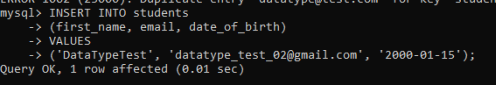
SELECT student_id, first_name, email, date_of_birth
FROM students
WHERE email = 'datatype_test_02@test.com';
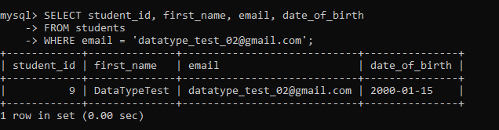

19. Step 16 — Default Value Testing
Test Objective: Verify that status defaults to Active.
INSERT INTO students (first_name, email)
VALUES ('DefaultTest', 'default@test.com');
SELECT first_name, email, status, registration_date
FROM students
WHERE email = 'default@test.com';
Expected: status = Active and registration_date should be automatically populated.
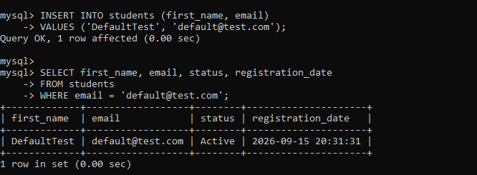

20. Step 17 — CRUD Testing

20.1 CREATE
INSERT INTO students (first_name, email)
VALUES ('CRUD', 'crud@test.com');
Verify:
SELECT * FROM students WHERE email = 'crud@test.com';
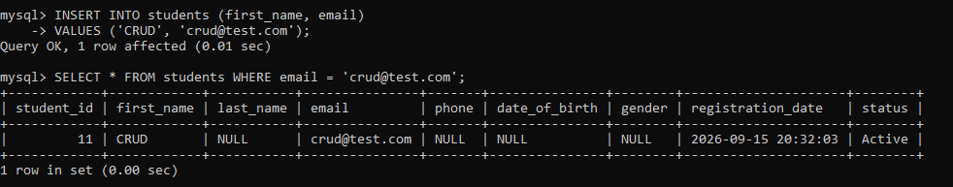

20.2 READ
SELECT * FROM students WHERE email = 'crud@test.com';
Expected: The newly created record is returned.
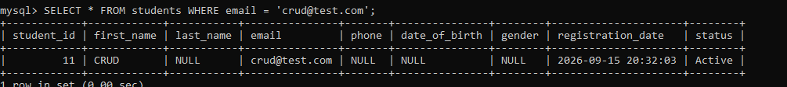

20.3 UPDATE
UPDATE students
SET phone = '01799999999'
WHERE email = 'crud@test.com';
SELECT * FROM students
WHERE email = 'crud@test.com';
Expected: Phone number should be updated correctly.
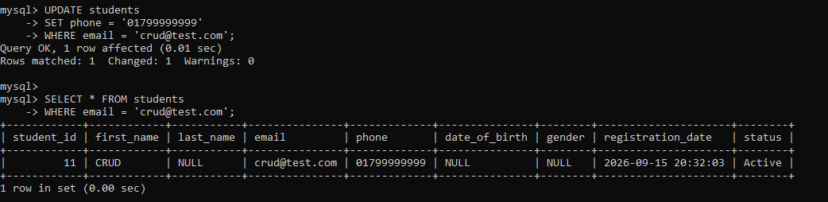

20.4 DELETE
DELETE FROM students
WHERE email = 'crud@test.com';
SELECT * FROM students
WHERE email = 'crud@test.com';
Expected: SELECT should return 0 rows.
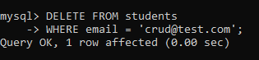

21. Step 18 — JOIN Testing
Question: Can we correctly retrieve the student, course and enrollment information together?
SELECT
s.student_id,
CONCAT(s.first_name, ' ', s.last_name) AS student_name,
c.course_name,
e.enrollment_status
FROM students s
JOIN enrollments e ON s.student_id = e.student_id
JOIN courses c ON e.course_id = c.course_id
ORDER BY s.student_id;
Expected: Each returned enrollment should show the correct student and course.
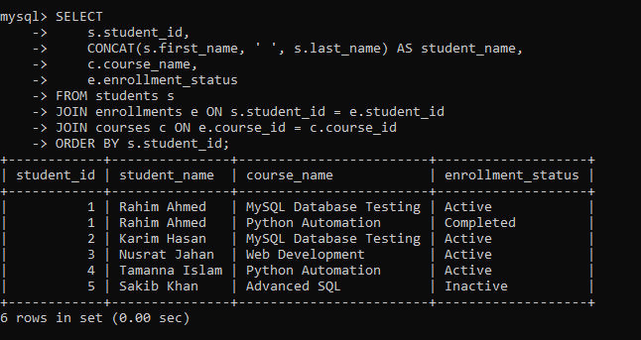

22. Step 19 — Instructor/Course JOIN Testing
SELECT
c.course_name,
CONCAT(i.first_name, ' ', i.last_name) AS instructor_name,
c.price,
c.level
FROM courses c
JOIN instructors i
ON c.instructor_id = i.instructor_id;
Expected: Every course should display its correct instructor.
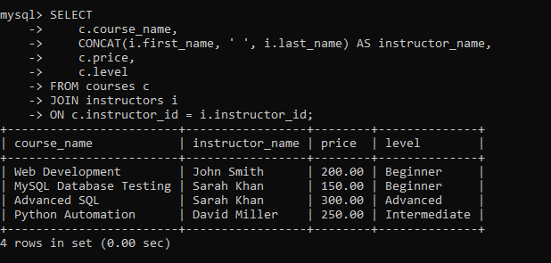

23. Step 20 — Payment Data Validation
Question: Are payment amounts matching the course price?
SELECT
p.payment_id,
s.first_name,
c.course_name,
c.price AS course_price,
p.amount AS paid_amount,
p.payment_status
FROM payments p
JOIN students s ON p.student_id = s.student_id
JOIN courses c ON p.course_id = c.course_id;
Review the result and identify any payment where paid_amount does not match the expected course price.
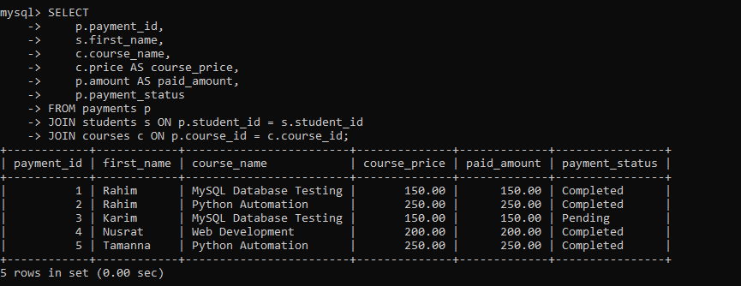

24. Step 21 — Find Data Inconsistency
Question: Is there any payment for which no matching enrollment exists?
SELECT
p.payment_id,
p.student_id,
p.course_id,
p.amount
FROM payments p
LEFT JOIN enrollments e
ON p.student_id = e.student_id
AND p.course_id = e.course_id
WHERE e.enrollment_id IS NULL;
Expected: 0 rows if every payment should belong to an enrolled student/course combination.
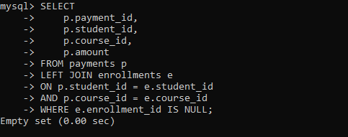

25. Step 22 — Aggregate Query Testing
Question: How many students are enrolled in each course?
SELECT
c.course_name,
COUNT(e.enrollment_id) AS total_enrolled
FROM courses c
LEFT JOIN enrollments e
ON c.course_id = e.course_id
GROUP BY c.course_id, c.course_name
ORDER BY total_enrolled DESC;
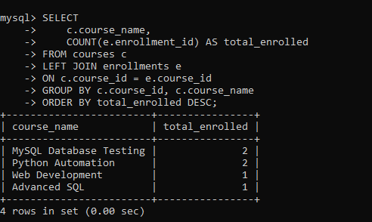
Question: What is the total completed payment amount?
SELECT SUM(amount) AS total_completed_payment
FROM payments
WHERE payment_status = 'Completed';
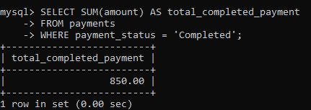
Question: What is the average course price?
SELECT AVG(price) AS average_course_price
FROM courses;
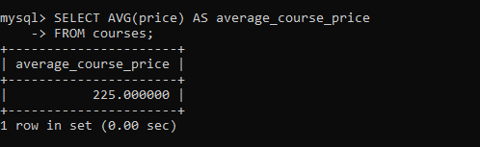

26. Step 23 — Review Validation
Question: Are ratings within the expected 1–5 range?
SELECT *
FROM course_reviews
WHERE rating < 1 OR rating > 5;
Expected: 0 rows.
Note: The current table does not enforce a CHECK constraint. A future improvement is to add a CHECK constraint for rating between 1 and 5.
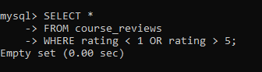

27. Step 24 — NULL Data Testing
Find nullable fields that contain NULL:
SELECT *
FROM students
WHERE last_name IS NULL
OR phone IS NULL
OR date_of_birth IS NULL;
This is not automatically a defect because those columns were intentionally defined as nullable. The tester should compare the result with business requirements.
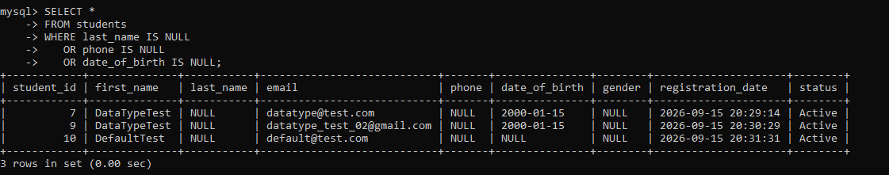

28. Step 25 — Status Validation
Question: Are unexpected student statuses stored?
SELECT DISTINCT status
FROM students;
Expected values for this project: Active and Inactive.
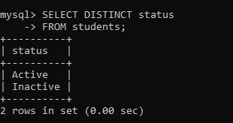

29. Step 26 — Search / Filter Testing
SELECT *
FROM students
WHERE status = 'Active';
Expected: Only active students are returned.
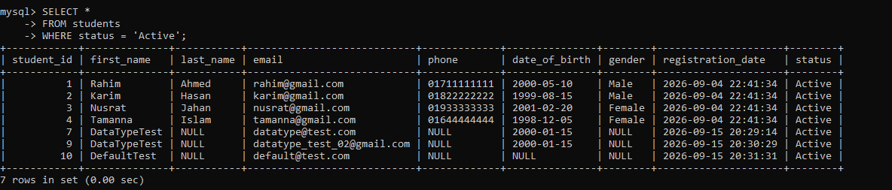
SELECT *
FROM courses
WHERE price BETWEEN 150 AND 250;
Expected: Courses priced from 150 through 250 are returned.
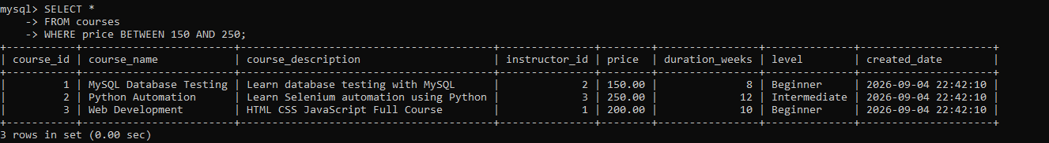

30. Step 27 — Sorting Testing
SELECT course_name, price
FROM courses
ORDER BY price DESC;
Expected: Course prices should appear from highest to lowest.
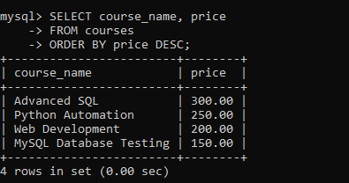

31. Step 28 — Transaction Testing
Transactions are useful when testing whether multiple database changes can be committed or rolled back safely.
START TRANSACTION;
UPDATE students
SET status = 'Inactive'
WHERE student_id = 1;
SELECT student_id, status
FROM students
WHERE student_id = 1;
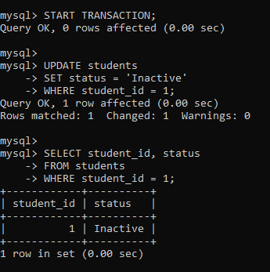
ROLLBACK;
SELECT student_id, status
FROM students
WHERE student_id = 1;
Expected: After ROLLBACK, the original status should be restored.
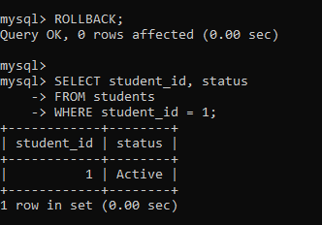

32. Step 30 — Final Regression Queries
Run these after test execution to confirm the database is still in a usable state.
USE course_management_db;
SHOW TABLES;
SELECT COUNT(*) FROM students;
SELECT COUNT(*) FROM instructors;
SELECT COUNT(*) FROM courses;
SELECT COUNT(*) FROM enrollments;
SELECT COUNT(*) FROM payments;
SELECT COUNT(*) FROM course_reviews;
SELECT * FROM students;
SELECT * FROM courses;
SELECT * FROM enrollments;
SELECT * FROM payments;
SELECT * FROM course_reviews;

33. Optional Clean-Up Script
Use only when you want to delete the test database and rebuild it from scratch.
DROP DATABASE course_management_db;
Warning: This permanently removes all tables and data inside this test database.

34. Project Completion Checklist
- Database/schema created
- All six tables created
- Primary and foreign keys verified
- Sample data inserted
- Row counts verified
- CRUD testing completed
- Negative testing completed
- Foreign key testing completed
- JOIN queries tested
- Aggregate queries tested
- Data consistency checks completed
- Test execution results recorded
- Final regression queries executed

End of Database Testing Project Guide

